Accommodation Request Met By Agreement Type

Accommodation | Academic | Towers | NorthView | Rosen
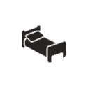  Private  Bedroom | No | Yes | Yes | Yes
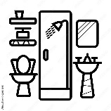  Private  Bathroom | No | No | Yes | No
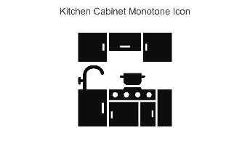  Kitchen  (in-unit) | No | Yes | Yes | Yes

- Yes = All units in this agreement type have this feature, so that an accommodation approval is not needed in order for the student to receive this feature. For example, all apartments in NorthView are either 4 bed/4 bath or 2 bed/2 bath, so anyone receiving housing at NorthView will automatically have a private bedroom and private bathroom, regardless of accommodation status.
- No = While it’s possible some units within this agreement type have this feature, not all of them do, so this feature will not be automatically provided by receiving this type of housing. For example, some communities within the Academic agreement have private bedrooms, but many are shared rooms.
- Private Bedroom = a single bedroom within a unit. For example, a bedroom in a 4 bed/2 bath apartment.
- Private Bathroom = bathroom within a unit that is only accessed by the resident. For example, a bedroom and bathroom in a 4 bed/4 bath apartment.
- Kitchen (in-unit) = a kitchen that is within the unit and is accessed by the residents of the unit, but is not accessed by an entire floor/wing of residents. For example, a 4 bed/2 bath apartment that has a living room and kitchen for the 4 residents of that unit.

