Accessible Courses by Design

Imagine a person who uses a wheelchair approaches a building where the only way to enter is via a set of stairs that lead to the only entrance. No ramp. No ground floor entry. The person who uses the wheelchair cannot get into the building. Is it that person’s fault that entry is not possible or is the issue with how society designed that building? What is the real barrier here?

Why is access so important? Disabled students must be able to engage in the same activities, access the same information, and enjoy the same experiences as a person without a disability, in an equally effective and real-time manner.

Accessible course design from the outset is best practice. When SAS collaborates with professors and students to facilitate an accommodation for a course, the accommodation is a reactive response to an aspect of the course that is not accessible, much like a building with no ground level or ramp entry.
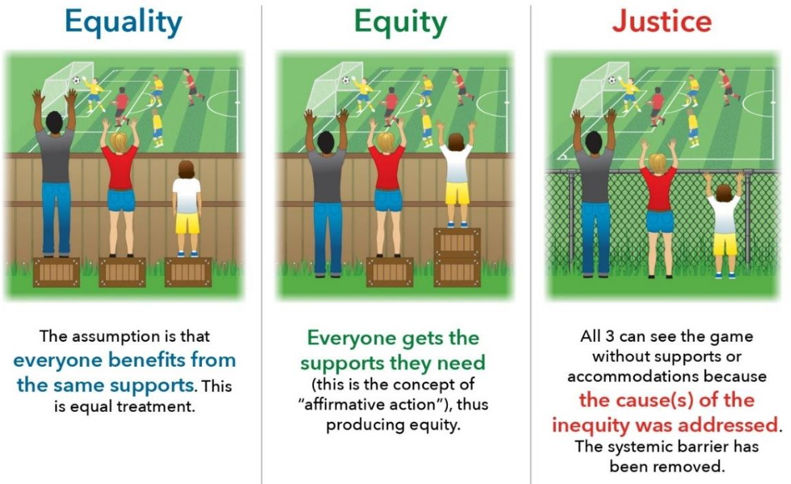

It is impossible to always make every course fully accessible. For example, there will always be the need for sign language interpreters when a deaf student fluent in sign language is present in the class. However, intentional course design can reduce the need for reactive accommodations.

While by no means an exhaustive list, the following access considerations can create a better experience for all students and reduce the need for accommodations.

Course Notes Access
- Identify a student or a rotation of students in the class to provide a copy of course notes for the benefit of all students. The specialized note-taking accommodation is then not necessary.
- Consider providing PowerPoint slides to students in advance of the class to assist with note-taking during class.

Auditory & Reading Access
- Only use videos where full, accurate captioning is an option.
- Offer syllabi in advance of the class so that students can read, review and process prior to the first day.
- Ensure all handouts and other course
materials are accessible. For example, PDF scans of articles cannot be read by text-to-speech software.
- When adopting required reading materials, confirm with the publisher that electronic text (e-text) formats are available for purchase.

Test, Quiz and Other Assessment Access
- Consider inclusive alternatives to pop, short in-class, and iClicker quizzes. Facilitating extra time on quizzes generally requires extra steps and logistical challenges for students and professors.
  - 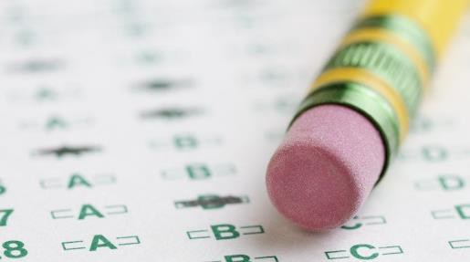Design tests with multiple means of assessment (multiple choice, true/false, essays, problems, etc.)
  - Take-home exams, where students are allowed multiple days to complete the work, most often eliminate the need for extra time for tests.
- Online exams allow the student to test in the same online environment as everyone else in class.
- Consider offering multiple assessment options when possible, such as allowing students to do a presentation, a video, or write a paper to fulfill the same course objective.

Course Activity Access
- Consider the extent to which course attendance is truly essential to the learning objectives. Make clear and logical connections.
- Balance adhering to course policies with recognizing extenuating case-by-case circumstances

